Positive Behaviour Policy



|  |  |  |
| --- | --- | --- |
| Agree Date | Review Date | Person Responsible |
| 2018 September | 2019 September | Mr Smith |

*“A whole-school policy is required: one which is developed, understood, accepted and operated with consistency by the whole school.” Pastoral Care in Schools: Promoting Positive Behaviour* *Para. 16*

**CONTENTS**

Pg.3 Tracking and Monitoring Calendar

Pg.4 Introduction

Our Ethos Statement

Governors’ Role

Pg.5 Our Values and Principles

Policy Aims, Outcomes and Evidence Trail

Pg.7 How Will We Achieve Our Aims and Outcomes

The Class Plan for Learning: Our Agreed

* Values
* Rights and Responsibilities
* Behaviours for Learning
* Rules
* Rewards, Sanctions and Support
* Tracking, Monitoring and Assessment

Whole-School Choices and Consequences

Pg.11 Classroom management

Pg.12 Whole School Stepped Sanction Framework

Pg. 13 Restorative Strategies

Community Expectations

Pg. 14 Table of Expectations

Pg. 15 Prohibited Items

Annual Efficacy Report to the Board of Governors

Resourcing

Pg. 16/17 Appendices

* Legislation and DENI Guidance
* Reasonable Force/Safe Handling
* Suspensions and Expulsions Procedures

**Our Positive Behaviour Policy is designed to:**

* Promote positive attitudes
* Keep unacceptable behaviour to a minimum
* Develop and maintain sound relationships
* Create and maintain an effective environment for learning

**Tracking and Monitoring Procedures: How effective is our policy in delivering these 4 aims?**

To assess how effectively the policy is being implemented, staff, pupils and Principal will monitor the areas identified in the table below. The data collected will be collated and the results obtained will inform and guide

* policy development and review
* development of the School Development Plan

|  |  |  |  |  |
| --- | --- | --- | --- | --- |
| **Evidence** | **Ongoing** | Collated by | | **Frequency** |
| Attendance Records | Class teacher and pupils | Principal | Termly | |
| Class/pupil Learning Behaviour rewards tracking sheets | Principal | Half-termly | |
| Class Unacceptable Behaviour Records | Principal | Half-Termly | |
| IBPs | SENCO | Termly | |
| House points | Principal | Termly | |
| Extended Activities Register | Principal | Bi-monthly | |
| Class wall displays | Principal | Half-termly | |
| Staff planners / lesson notes | Co-ordinators & Principal | Half-termly | |
| Results | Co-ordinators & Principal l | Termly | |
| Minutes – School Council/PTA | Class Assistant/PTA secretary | Principal | Bi-Monthly | |

**Introduction**

In Upper Ballyboley Primary School we are committed to creating a happy, safe, caring environment where children participate, excel and are proud of their achievements.

This whole-school policy which is based on current legislation and the DENI Guidance regarding the development and implementation of a Positive Behaviour Policy if consistently implemented is designed to enable this positive ethos to flourish and grow. The policy forms part of the suite of pastoral policies which includes, Child Protection and Safeguarding, together with the Anti-bullying Policy.

This policy is owned by the members of the school community because they have regular opportunities to contribute to its development through:

* Baseline consultation with members of the school community-e.g. in October and June, using specific audits to identify our current strengths and areas for development (Audits/SDP)
* Opportunities for ongoing pupil participation through the developing School Council whose members have opportunities to contribute to and reflect on the development of this policy (Mins)

**Ethos Statement**

Here in Ballyboley Primary School we are committed to creating a happy, safe, caring environment where children participate, excel and are proud of their achievements.

**The Role of the Board of Governors**

DENI guidance sets out the following role for Governors. They must:

* ensure that good behaviour and discipline policies are pursued at the school;
* make and keep under review, a written statement of ‘general principles’ about pupil behaviour and discipline,

**Our Values and Principles**

As part of the Governors’ remit staff and Governors representatives meet together to review current values as expressed in the school’s prospectus and consider the implications of ‘Every School a Good School’ and recent DE circulars re Pupil Participation (2014/14) and School Development Planning (DENI 2010) for the ongoing Positive Behaviour Policy Review.

The values identified then became the basis on which the Governors drew up their set of Written Principles which set out the standard of behaviour expected from every member of the school community.

The outcomes of this work are reflected in the diagram below:

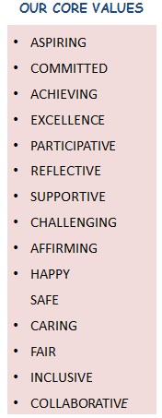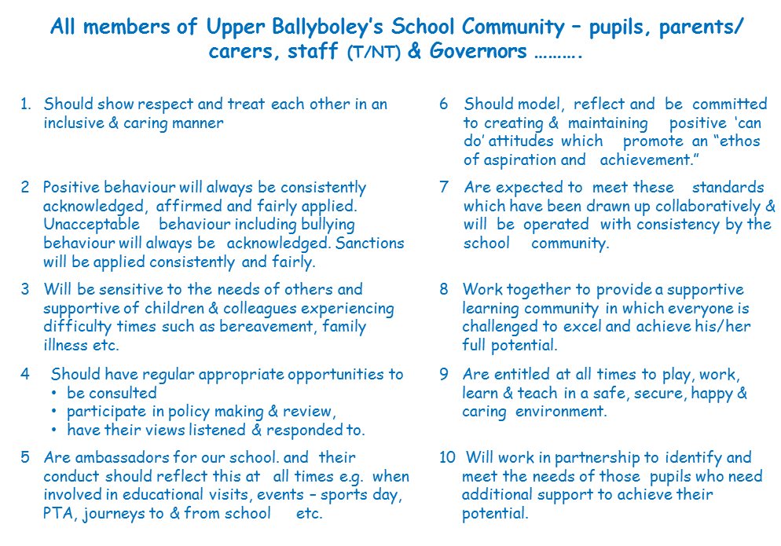

Pupils through the School Council, staff and parents have an opportunity to reflect on the principles and share their views.

**Positive Behaviour Policy: Aims and Outcomes**

Positive Behaviour Policies have 4 clear aims which together contribute to the creation of a happy secure learning ethos: They are to:

1. Create and promote the positive attitudes
2. Reduce unacceptable behaviour and ensure an orderly and purposeful environment
3. Create A Climate Conducive To Sound Relationships
4. Create A Climate Conducive To Effective Learning & Teaching

Governors and staff met together to discuss and agree how to implement these policy aims and objectives. The table below represents the outcomes of this meeting which have been discussed and agreed with the School Council members before being sent out to parents for their comments. To assess the efficacy of the policy staff will track, monitor and evaluate progress based on the evidence trail identified below.

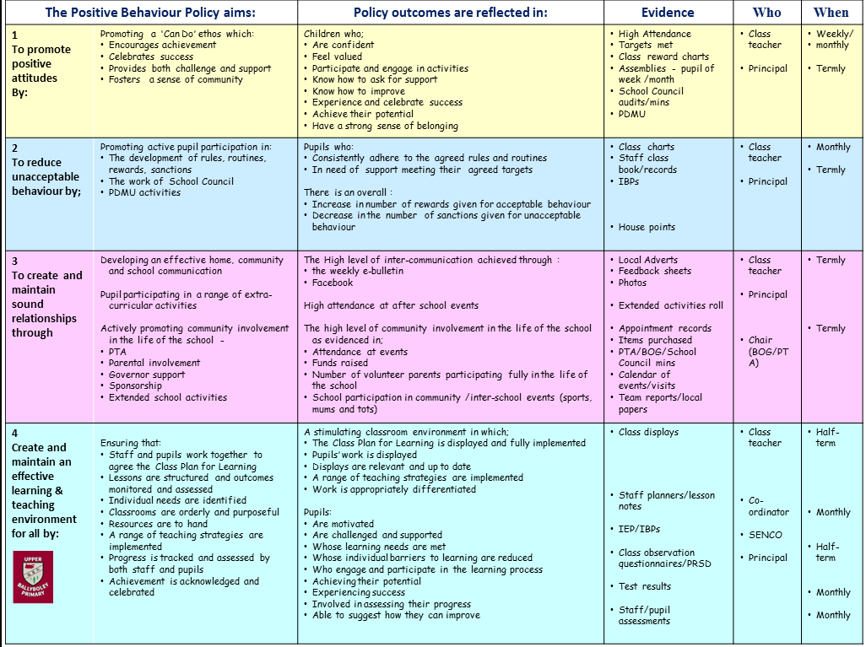

POLICY AIMS OUTCOMES EVIDENCE TRAIL WHO WHEN

**How Will We Achieve these Aims?**

All members of the school community will work together in Upper Ballyboley to create:

* A positive atmosphere where everyone has the opportunity to achieve and celebrate success
* An agreed positive system of rewards which consistently acknowledges and affirms achievement
* A community in which everyone models positive behaviour and leads by example.
* Positive interpersonal development through active pupil participation in the Personal Development and Mutual Understanding lessons.

And through the development in each classroom of an agreed Class Plan for Learning which when implemented consistently across the school will result in more effective teaching and learning.

THE PROCESS

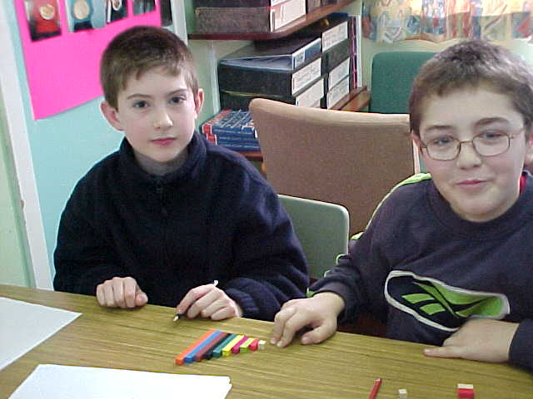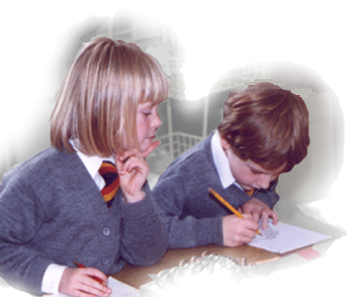

**1**

Values

**3**

**Learning**

**Behaviours**

**4**

Rules

& Routines

**5**

Rewards & Sanctions

**2**

Rights &

Responsibilities

**CLASS**

**PLAN FOR**

**LEARNING**

**The Class Plan for Learning** complements the Assessment for Learning process as it promotes pupils taking responsibility for their own behaviour

Overleaf is a sample Class Plan for Learning. Together pupils and staff identified and agreed the key learning behaviours which promote effective teaching and learning in the classroom.

In each class pupils and staff work through the 5 stages of the process to identify key:

* Values
* Rights and responsibilities
* Behaviours for Learning
* Rules and routines
* Rewards and sanctions

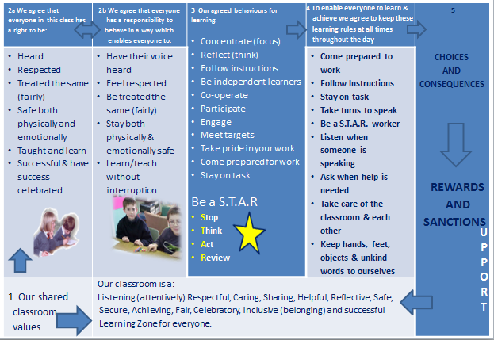HERE IS A SAMPLE CLASS PLAN FOR LEARNING

THE CLASS PLAN FOR LEARNING focuses on:

* Providing opportunities for pupils to be part of the decision making process within the classroom
* Developing good learning behaviours
* Creating an effective learning environment
* Enabling young people to take responsibility for their behaviour
* Reducing interruptions to the learning and teaching.
* Rewarding those pupils who choose to develop very effective learning behaviours
* Sanctioning those pupils who choose not to comply with the agreed learning behaviours
* Identifying and meeting individual learning needs
* Establishing a consistent whole-school approach to classroom management

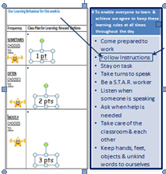



I sometimes choose to listen in class when the teacher is speaking

What action/s/target/s can we agree & implement to help Joan improve her listening behaviour ?

**SUPPORT: Reducing barriers to learning** To assist those children who regularly have difficulty in achieving rewards for their learning behaviours, pupils and staff together identify and agree individual targets. Progress made in helping pupils develop more effective learning behaviours will be tracked, monitored, reviewed and assessed by both pupils and staff. (See SEN policy for Code of Practice details)

THE CLASS PLAN FOR LEARNING: REWARDS

Once the plan is agreed all the learning behaviours are always in play but for the purpose of rewards the focus is placed on one specific behaviour for learning

**THE PROCESS**

Each week the staff and pupils choose to focus on one of the agreed behaviours for learning E.g*.* ***Listen when someone is speaking***

For an agreed period of time (varied) each day, pupils and staff focus on this behaviour and together monitor the frequency to show how well individual pupils are managing to reflect this learning behaviour.

**THE POINT & COLOUR SYSTEM IS AGREED WITH PUPILS**

The colour of the different beads = the frequency level achieved. Together staff and pupils monitor the levels achieved:

**3** pts = during MOST of the agreed period of time the pupil is choosing to listen

**2** pts = OFTEN during this agreed period of time the pupil is choosing to listen

**1** pt = SOMETIMES during this agreed period of time the pupil is choosing to listen

At the end of the agreed period pupils are awarded the coloured bead which is added to form a bracelet. At the end of the week the number of beads achieved is recorded. Pupils requiring support with this learning behaviour are identified. Targets are agreed, set and tracked to monitor progress.

**Class Plan For Learning- REWARDS: Tracking Monitoring and Assessment**

Over a six week period in each term, staff and pupils will focus on developing 3 learning behaviours which have been identified and agreed in the Class Plan for Learning. Pupils and staff together will track and record on a frequency basis how effectively each learning behaviour is being developed. The reward system is discussed and agreed with the pupils. The system aims to establish in every classroom a climate for learning which enables everyone to learn and the teacher to teach.

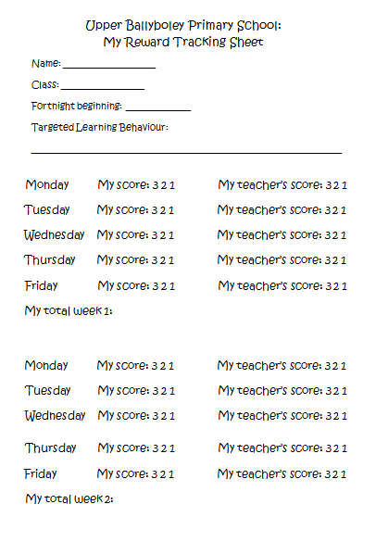See exemplar below

This tracking system will help staff to identify those children who regularly experience difficulty in mastering one or more of the identified learning behaviours. Individual target/s will be agreed with these pupils and support put in place to help them achieve the target behaviour for learning so that they reduce their barrier/s to learning and achievement in class improves.

Outcomes will be tracked and monitored and at the end of each term pupils will be presented with one or other of the following certificates – LB Bronze, LBSilver or LB Gold to reflect the level of attainment gained.

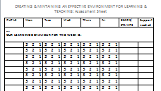Top performing classes will be acknowledged with, for example, a class certificate and Top performing pupils will be acknowledged and their success celebrated.

Where a pupil has significantly greater difficulty in mastering one or more of these learning behaviours, he/she will be supported through being placed on the Code of Practice. Individual progress will be monitored by the school SENCo who, if required, will seek further external support from the Education Authority through, for example, support from the Autism Service (ASD), Behaviour support Service (BSS) etc. (See Special Education Needs Policy for further details)

**WHOLE-SCHOOL: CHOICES AND CONSEQUENCES**

**Choices**

Rewards and sanctions are but the consequences of our choices. Good appropriate choices mean acknowledgement and affirmation. Poor unacceptable choices mean disapproval, deterrents and support.

Our approach to creating a positive ethos within the school is to treat children positively, by praising them, offering them encouragement and acknowledging their achievements. We will ensure children know that their effort, achievement and good behaviour are recognised and valued by means of a range of rewards:-

* Stickers
* Certificates
* Weekly awards for, work, friendship and creativity.
* Praise, in class, in assembly or by the Principal for good work or behaviour.
* Share good work with another class or member of staff
* Parents informed of good work

All classes will have the rewards displayed in the classroom. As well as acknowledging and celebrating the individual efforts and successes, children are encouraged to work collaboratively as a team and gain points for their house teams. Winning teams are celebrated in a weekly, whole school assembly and extra playtime is awarded.

**Classroom Management**

* Classroom management and teaching methods have an important influence on children’s behaviour. The classroom environment gives clear messages to the children about the extent to which they and their efforts are valued.
* Classrooms should be organised to develop independence and personal initiative. Furniture should be arranged to provide an environment conducive to on-task behaviour. Materials and resources should be arranged to aid accessibility and reduce uncertainty and disruption.
* Displays should help develop self-esteem through demonstrating the value of each individual’s contribution and overall the classroom should provide a welcoming environment.
* Teaching methods should encourage enthusiasm and active participation for all. Lessons should aim to develop the skills, knowledge and understanding which will enable the children to work and play in co-operation with others.
* Praise should be used to encourage good behaviour as well as good work.

**Consequences**

When we discuss inappropriate behaviour, we will encourage children to consider alternative choices they could have made which would have resulted in a more positive outcome. Everyone is expected to make things better put things right where possible. Consequences of inappropriate pupil behaviour may be:

* The child will be asked to think about what he/she has done wrong and what other choices could have been made.
* Loss of privileges (Eg: miss ….. minutes of playtime)
* Work may be finished at playtime under supervision
* A child’s parents informed
* A child may be sent to another class for “time out” to reflect upon their behaviour.
* The child may be sent to the Principal
* A detention may be given and parents informed
* A child may be suspended from school (this would only occur following a serious breach of school rules and when every other option has been tried. (see EA Guidelines for details of process).
* If a problem arises the children involved will have the opportunity to offer an explanation

We will always try to be fair and promote restoration.

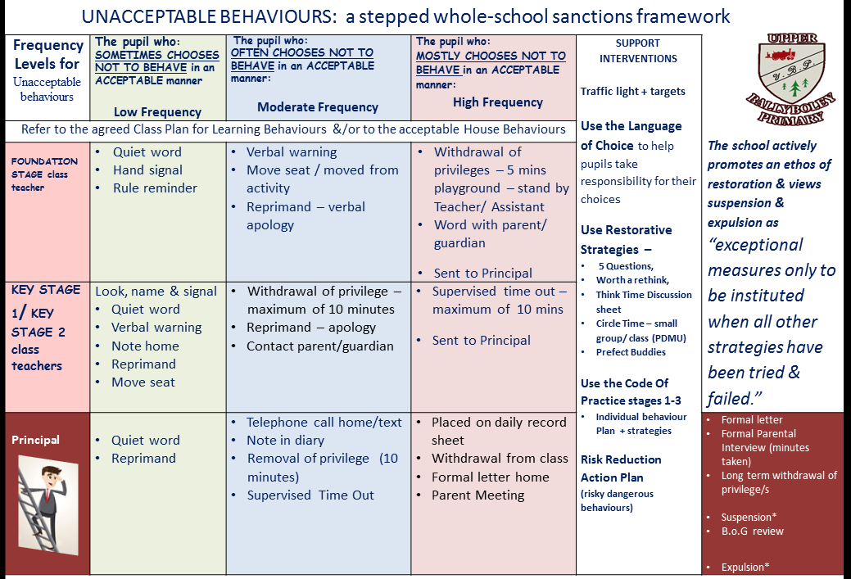

**The suspension procedures followed will be those set out in School (Suspension and Expulsion of Pupils) Regulations 1995/Schools (Suspension and Expulsion of Pupils) (Amendment) Regulations (Northern Ireland) 1998 & Suspension and Expulsion Procedures, DE 2004**

School work will be provided for a suspended pupil and marked on return to school**. (Parents are responsible for collecting and returning this work.)**

Restorative Strategies which Rebuild and Repair relationships

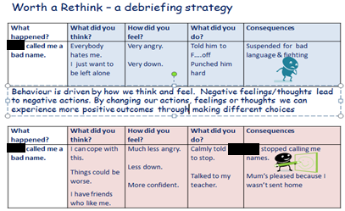

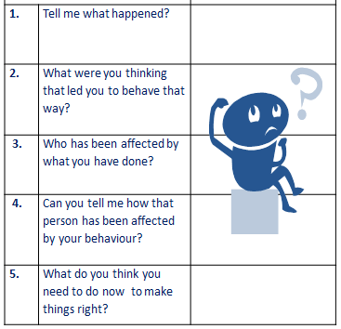

**The 5 Questions**

**COMMUNITY EXPECTATIONS**

To create our desired ethos we believe that every member of our school community should meet the expectations outlined below.

|  |  |
| --- | --- |
| **DESIRABLE BEHAVIOURS** | **UNDESIRABLE BEHAVIOURS** |
| * Appropriate dress * High attendance – 95% plus * Punctuality – arrive on time * Polite, well-mannered mutual respect * Respect for property (school environment/own) * Honesty * Tolerance and acceptance | * Inappropriate dress * Erratic attendance, no note provided * Lateness * Impolite, rudeness * Fighting /aggressive behaviour * Swearing/being disrespectful * Theft, Vandalism/disrespect for property * Dishonesty * Intolerance |
| * Deadlines met * Correct equipment | * Deadlines missed * Incorrect equipment |

*Bullying behaviour of any kind by any member of our school community to any member of our community is never acceptable – see Anti-Bullying Policy for details*

**EXPECTATIONS:**

|  |  |  |  |
| --- | --- | --- | --- |
| **Staff - non-teaching and teaching - will be expected to:**   * Provide a consistent approach across the whole school * Model appropriate behaviour. * Promote honesty and courtesy by example. * Provide a caring and effective learning environment. * Encourage relationships based on kindness, respect and understanding of the needs of others. * Show appreciation of the efforts and contributions of all within the school. * Ensure fair treatment of each individual, regardless of age, gender, race, ability and disability. * Follow the agreed behaviour policy and support each other in doing so. | **Children will be expected to:**   * Treat others as they would like to be treated. * Respect others, regardless of age, gender, race, ability and disability. * Accept responsibility for their choices. * Contribute to and follow the agreed behaviour expectations. * Contribute to and follow school rules. * Demonstrate good manners. * Take care of their personal appearance and belongings. * Work collectively within their classes and teams. | **Parents/carers will be expected to:**   * Support the school so children receive consistent messages about how to behave both at home and at school. * Support and encourage their child’s learning. * Inform the class teacher should any concerns arise about behaviour. | **The Principal will be expected to:**   * Consult with pupils and parents/carers * Promote pupil participation * Implement the school behaviour policy consistently throughout the school * Ensure the health, safety and welfare of all children in the school. * Celebrate examples of exemplary behaviour with the whole school. * Support the staff in implementing the behaviour policy. * Keep records of all reports of incidents of serious misconduct, with action taken. * Deal with serious, unacceptable behaviour. |

*.***Prohibited Items;**

For reasons of Health and Safety and to prevent lass of personal items which are not covered by insurance staff will confiscate the items listed below should they be brought into school.

Any confiscated item/s apart from a dangerous weapon* will be returned to the pupil at the end of the school day.

* Mobile phones
* Portable electronic devices
* Metal Jewellery (Gold, Silver etc.)
* Chewing Gum – to enable cleaning staff to maintain a clean and pleasant environment for all
* Dangerous weapon/s* – Principal will contact the parents to arrange for collection at the end of the school day

**In Upper Ballyboley we will:**

* Respect everyone and celebrate our differences.
* Look after each other and try to be honest and show care by solving disagreements peacefully.
* Use our best manners and be helpful to everyone.
* Listen carefully to each other and try our very best in all we do.
* Move around the school quietly and safely.
* Take care of our school property and belongings.
* Show respect for ourselves, our friends and all in our school

**THE ANNUAL REPORT TO THE BOARD OF GOVERNORS**

The policy will be reviewed annually by the Principal and a “*succinct report on the findings*” submitted to the Board of Governors, to inform how effectively “*they are fulfilling their statutory responsibilities*” for promoting positive behaviour and safeguarding pupils.

*“Where weaknesses are found, a review will be necessary. All of the staff, teaching and non-teaching, and the pupils and Governors, should contribute to this review. …. Where significant changes are contemplated, parents should also be consulted, and, in any event, should be consulted periodically (say every 3 years).”*

*Pastoral care in Schools; Promoting Positive Behaviour, DENI, 2001*

Annually the Principal will present a report to the Governors detailing the extent to which the Positive Behaviour Policy is delivering its agreed outcomes and the extent to which staff are promoting positive behaviour management consistently across the school.

**RESOURCING THE POLICY**

CPD; Staff will be encouraged to attend relevant training when available – e.g. in Understanding Autism, ADHD etc. PRSD will be used to identify staff needs.

**APPENDICES**

**LEGISLATION GOVERNING A SCHOOL’S POSITIVE BEHAVIOUR POLICY**

**Our policy development complies with the legislation listed below:**

* The Health & Safety at Work (NI) Order 1978
* Education (NI) Order 1998 – Articles 3 - 6
* The Welfare and Protection of Pupils’ Education and Libraries (NI) Order – Articles 17 & 19
* The Education (2006 Order) (Commencement NO.2) Order (NI) 2007 – Articles 18 – 20

**The following publications inform and guide** the development, monitoring and review of our current policy and practice;

* Promoting and Sustaining Good Behaviour: A Discipline Strategy for Schools DENI 1998
* Pastoral Care in Schools: “Promoting Positive Behaviour” DENI 2001
* Every School a Good School A Policy for School Improvement DENI, 2009
* Together Towards Improvement A Process for Self-Evaluation, Primary, ETI, 2010
* Resource File for Special Educational Needs, DENI, 2011

This policy has evolved though:

* consultation with members of our school community - involving completion of audits/surveys
* in-service training for staff and Governors teaching and non-teaching staff,
* ongoing pupil participation - in the development of The Class Plan for Learning; in Self-Assessment and in the work of our School Council

**REASONABLE FORCE/SAFE HANDLING**

To reduce the need for any form of physical intervention, except in emergency situations, our staff actively implement a range of positive and restorative strategies. However should a need arise for physical intervention, staff follow the guidelines set out in the “Regional Policy Framework on the use of Reasonable Force/ Safe Handling.” May, 2004 – see extracts below;

***“the working definition of “reasonable force” is the minimum force necessary to prevent a pupil from physically harming him/herself or others or seriously damaging property, but used in a manner which attempts to preserve the dignity of all concerned.”***

*“Reasonable force/safe handling can be used by a teacher or other authorised person(s) on the school premises or when authorised elsewhere eg, supervision of pupils in bus queues, a field trip, on other authorised out of school activities such as a sporting event or educational trip. Reasonable force should be limited to emergency situations and used only as a last resort when all other behaviour management strategies have been exhausted and where:*

*• action is necessary in self-defence or because there is imminent risk of injury to another pupil or person;*

*• there is a developing risk of injury to another pupil or person, or significant damage to property;*

*• a pupil is behaving in a way that is compromising good order and discipline.”*

Staff use preventative strategies to defuse and de-escalate potentially confrontational and/ or aggressive situations. In specific situations such as those described below a Risk Assessment may be required.

*“A small number of pupils may exhibit disturbed or distressing behaviour which may require some form of physical intervention by staff. To minimise the risk of incidents escalating unnecessarily due to lack of foresight, planning and training, schools should carry out a risk assessment from two perspectives:*

*• environmental risk assessment; and*

*• individual risk assessment”*

**SUSPENSIONS AND EXPULSIONS**

SUSPENSION PROCEDURES

While we actively work with pupils to maximise their access to learning there may be occasions when suspension and/or expulsion may be considered necessary – see extract below.

***“Only the principal/or his/her representative may formally suspend a pupil;***

* ***when all other internal interventions have been tried and failed***
* ***a dangerous situation arises posing a significant threat to the safety of one or more persons***
* ***For a maximum of 45 days over the school year***

In such circumstances the Principal/or his/her representative: “***shall immediately:***

* ***Give written notification of the reasons for and the period of suspension to the parent, to the Education Authority and the chairperson of the Board of Governors;***
* ***Invite the parent of the pupil to visit the school to discuss the suspension;***
* ***The Principal shall not extend a period of suspension without the prior approval of the chairperson of the Board of Governors and shall, in every case, give written notification of the reasons for the extension and the period of extension to the parent of the pupil and to the education authority;”***

*Should a pupil be suspended for more than a day the school will provide work to be done at home. Parents/carers are responsible for ensuring this work is collected, completed and returned to school for marking.*

**EXPULSION PROCEDURES**

* *A pupil may be expelled from school only after serving a period of suspension;*
* *A pupil may be expelled from a school only after consultation about his expulsion has taken place between the Principal, the parent of the pupil, the Chief Executive or another authorised officer of the Education Authority and the chairperson of the Board of Governors. Any neglect or refusal on the part of the parent to take part in such consultations, shall not prevent a pupil being expelled from the school.*
* *These consultations must include consultations about the future provision of suitable education for the pupil concerned;*
* *A pupil may be expelled only by the expelling authority. The expelling authority is the Education Authority for controlled schools and the Board of Governors for all other grant-aided schools;*
* *Where a pupil is expelled from the school, the expelling authority must immediately give written notification to the parent of his/her right to appeal the decision to expel the pupil, of the time limit set by the education authority for lodging the appeal and of where the appeal may be lodged.*

For further details see:

“Pastoral Care in Schools; Promoting Positive Behaviour,” DENI, 2001;

“Suspension and Expulsion Procedures,” DENI, 2004.