

**Pool Table Maths**

This is a special mathematical pool table. It has only two

pockets, one at the bottom left corner and the other at the top right corner.

To play pool on this table you only use one ball. It is hit from the bottom left hand corner and strikes and rebounds off each cushion at an angle of 450.

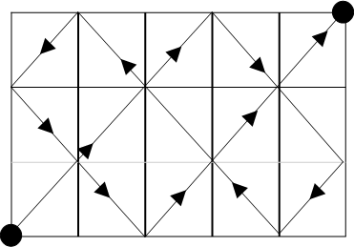

On a 3 x 5 table you will be able to pot the ball.

Now use squared paper to try pool tables with the following

dimensions and work out on which tables you will be able to pot the ball.

Try other table sizes. What do you notice?

|  |  |  |
| --- | --- | --- |
| **Table** | **Pot** | **Not Pot** |
| 7 x 3 |  |  |
| 3 x 4 |  |  |
| 6 x 7 |  |  |
| 7 x 5 |  |  |
| 9 x 3 |  |  |

**KS2C**

**Visual/Diagram Problems**