ATTENDANCE POLICY

Agree Date | Review Date | Person Responsible
2020 Sept | 2021 Sept | Mr Smith

The pastoral care of our children is central to the aims, ethos and teaching programmes in Upper Ballyboley Primary School and we are committed to developing positive and caring attitudes in our children and staff. Our Attendance Policy is part of our collective pastoral care policies.

Principles

Upper Ballyboley Primary School aims to provide support to parents and carers to ensure that all children of compulsory school age attend school regularly and maintain a pattern of good attendance throughout their school career.
We believe high levels of attendance and a punctual start to the school day are important to all children. School education lays the vital foundations of a child’s life. Research clearly demonstrates the link between regular attendance and educational progress and attainment. Parents, carers and school staff should work in partnership in making education a success and ensuring that all children have a full and equal access to all that the school has to offer. As a school we will encourage parents/carers to ensure that their child achieves maximum possible attendance and that any problems that prevent this are identified and acted on promptly. It is the parents’ responsibility to ensure that their child arrives to school and returns home safely.
Children and young people who regularly miss school without good reason are more likely to become isolated from their friends, to underachieve in examinations and / or become involved in anti-social behaviour.

Our aim is to ensure that every pupil has access to the full time education to which they are entitled and as a result ‘succeed and thrive’. We endeavour for children to take responsibility for their own attendance, recognising the link between attendance and good learning.
As stated, an important factor in pupil achievement is school attendance. The significant majority of our children enjoy their time at school as evidenced by a number of key indicators.
- High Level of Whole School Annual Attendance. This is consistently > 95%
- Low level of poor attendance i.e. < 85%
- Positive outcomes to the majority of attendance related issues.
- Each year many children have 100% attendance.
- Positive feedback from parents on an on-going basis about school and school-based activities.

Upper Ballyboley Primary School Expectations
We expect that all our pupils will:
- Attend school every day
- Attend school punctually• Attend appropriately prepared for the day (i.e.; Homework, PE kit, reading packs, etc.).
We expect that our parents/carers will:
- Ensure regular school attendance and be aware of their legal responsibilities by ensuring their children attend school regularly and arrive to school on time.
- Ensure that their child arrives at school punctually and prepared for the school day.
- Ensure that they contact the school either:
- On the first day of absence, by telephone, before 9am or
- In writing, detailing the reason for absence on the first day back after absence
- Where this does not happen teachers issue the parent with a “fill-in” proforma.
- Notify school immediately of any changes to emergency contact details.

We expect Upper Ballyboley Primary School will:
- Provide a welcoming atmosphere
- Provide a safe learning environment
- Keep regular and accurate records of attendance and punctuality and monitor each individual child’s attendance and punctuality
- Upper Ballyboley Primary School follows up on absences to:
- Ascertain the reason
- Ensure the proper safeguarding action is taken
- Identify whether the absence is authorised or unauthorised.
- Promote good attendance and punctuality and reduce absence through a system of reward and recognition
- Regularly inform parents of the % attendance of all pupils
- Where appropriate, inform parents / carers via a series of letters regarding their child’s punctuality and poor attendance. (Copies of all letters are enclosed at the back of the policy)
- Ensure every pupil has access to full-time education to which they are entitled
- Act to address patterns of absence
- Endeavour to keep in contact with families during a prolonged or significant absence.

Promoting and Celebrating Good Attendance
The school acknowledges that good attendance should be recognised and rewarded.

- (From 2017 / 18 on wards) At the end of the school year 100% Attendance Certificates are awarded at our Prize Distribution.

Notifying Absences
- Every absence from school has to be classified by the school (not by the parents), as either authorised or unauthorised. This is why information about the cause of any absence is always required.
- Details how to inform school about an absence are noted above.
- If the absence is prolonged i.e. requires hospitalisation or is particularly significant, parents are requested to keep school informed.
- Sometimes a child may be reluctant to attend school. Where this is the case, we believe that effective home / school communication contributes to a solution. This will help us to identify the root cause of the reluctance to attend and plan the way forward together.

Authorised Absences
From time to time children need to be absent from school for other reasons such as medical appointments. Such absences usually only take up part of a day. School should be informed of such absences in writing in advance, with accompanying documents and children should be brought in to school for morning registration and back to school straight after the appointment.

Every effort, however, should be made to arrange medical appointments outside school hours. Every single day a child is absent from school equates to a day of lost learning.

100% Attendance | 0 days missed | Excellent
95-99% Attendance | Between 1 – 9 days missed | Good – Very Good
95% Attendance | 9 days of absence  1 week and 4 days of learning missed | Satisfactory
90% Attendance | 19 days of absence  3 weeks and 4 days of learning missed | Poor
85% Attendance | 28 days of absence  5 weeks and 3 days of learning missed | Very poor
80% Attendance | 38 days of absence  7 weeks and 3 days of learning missed | Unacceptable
75% Attendance | 46 days of absence  9 weeks and 1 day of learning missed | Unacceptable
The table above is based on DENI guidance – School Attendance Matters – A Parent’s Guide.
Examples of authorised absences are:
- Illness;
- Religious observance by the religious body to which the child’s family belongs;
Examples of absences allowed by the school are:
- medical appointments
- exclusions
- family occasions e.g. close family wedding, bereavement etc.
- extreme family emergencies e.g. house fires, burglaries etc.
Unauthorised Absences
Unauthorised absences are those which the school does not consider reasonable and for which no “leave” has been given.
Examples of unauthorised absences are:
- Parents/carers keeping children off school unnecessarily
- Unexplained absences i.e. the absence has never been properly explained to school
- Shopping, looking after other children or birthdays
- Day trips or holidays in term time
- Truancy

Holidays During Term Time
- Parents demonstrate their commitment to their child’s education by not taking holidays during term time. Any child who is absent from school during term time due to holiday will miss out on important learning and may fall behind with their school work.
- Holidays taken during term time will be categorised as unauthorised absences. Under current legislation Upper Ballyboley Primary School may not grant any leave of absence during term time unless there are exceptional circumstances. Therefore, our school will only authorise holidays in line with these regulations. Exceptional circumstances will only be agreed very rarely.
- Parents should inform school by letter if they are going on holiday. We appreciate the courtesy of this information although, usually, we cannot authorise the absence.
Persistent Absenteeism
The school will continuously monitor each child’s attendance record. The school follows a two-step process for any children who are persistently absent for any reason:
1) Each half term the Principal will review all absences and the reasons given for children whose attendance falls below 85% as a cumulative percentage. It is noted if attendance is improving or deteriorating within the previous month. Following this analysis a range of action may result:
- School may phone parents to discuss the matter and offer support.
- School may send a letter to the parents/carers of specific children whose attendance is causing concern. This will inform parents of their child’s attendance, school’s concerns and invite parents to contact school to avail of assistance in effecting improvement.
Very often these early interventions are successful in effecting improved attendance.
2) The list of children whose attendance is below 85% is also discussed with the Educational Welfare Officer on a termly basis and where school’s action has not resulted in improved attendance, formal referral to the Educational Welfare Service will be discussed / agreed.
The Principal will liaise with the class teacher, SENCO and, when necessary, other professionals, if the need for support is identified.
Punctuality, Registers, Punctuality and Lateness
Punctuality to school is crucial. Lateness into school causes disruption to that individual’s learning and to that of the other pupils in the class. It is paramount therefore that all pupils arrive at school on time.
All children should be in the playground at 0850 ready to come into school at 0900, when the bell rings. By this time the children should have said their goodbyes and be lined up with their class in the correct place. This creates a positive start to the school day and allows learning to commence promptly.
At 0905; the register will then be closed, this is a legal requirement.
Whilst COVID-19 social distancing regulations remain in place, the children are to arrive at school at their allocated time. Their allocated time is likely to change depending on the duration of social distancing.
Lateness
Poor punctuality is not acceptable. If your child misses the start of the day they can miss work and the time with their class teacher getting vital information and news for the day. Late arriving pupils also disrupt lessons. This can be embarrassing for the child and can encourage absence.
A child arriving after 0900 is late. This matter is initially addressed by the class teacher. If work is missed there is an expectation that this will be ‘made up’ by the child.
A child arriving after 0900 will need to come to the main school entrance.
Registers
Registers are typically taken at the start of the school day. A child who is late into school will have received an L code (late mark) for that day. Should a child arrive after registers are closed it requires a further change to be made. If a child does not arrive into school a D code is used. This equates to an unauthorised absence and will be recorded as such on a child’s annual attendance record. However, on a child’s return, where a reason is provided, the D code is changed for example to I for illness.
If a child arrives after registers have closed – for reasons not considered acceptable by the school – they will be recorded as ‘Late after registers closed’. They are marked as being on site but this does not count as a present mark and will show as an unauthorised absence and affect their attendance record.

School Illness Guidelines
Please check that your child knows how to wash his/her hands thoroughly to reduce the risk of cross-infection. School attendance could be improved for all if children and families wash and dry their hands well five or more times a day.
The information below has been provided by the Health Protection Agency:
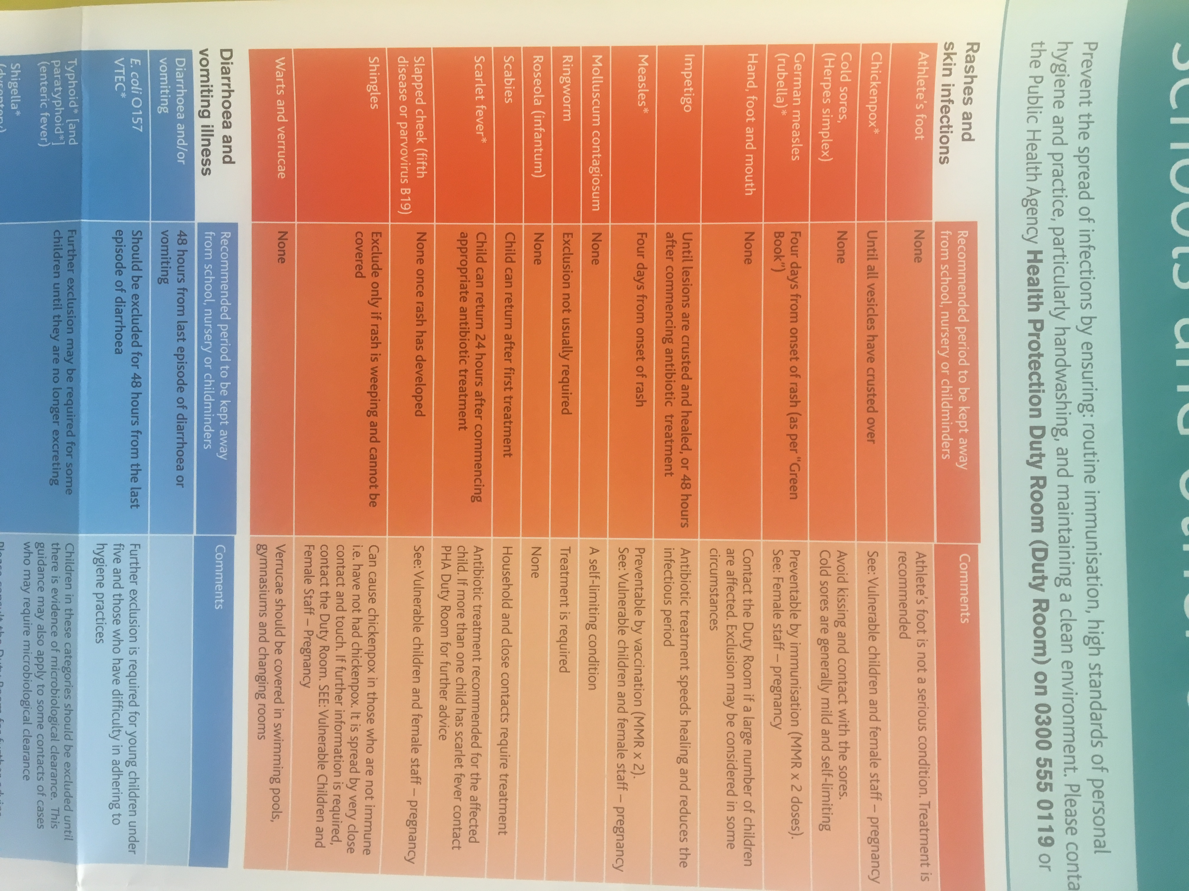
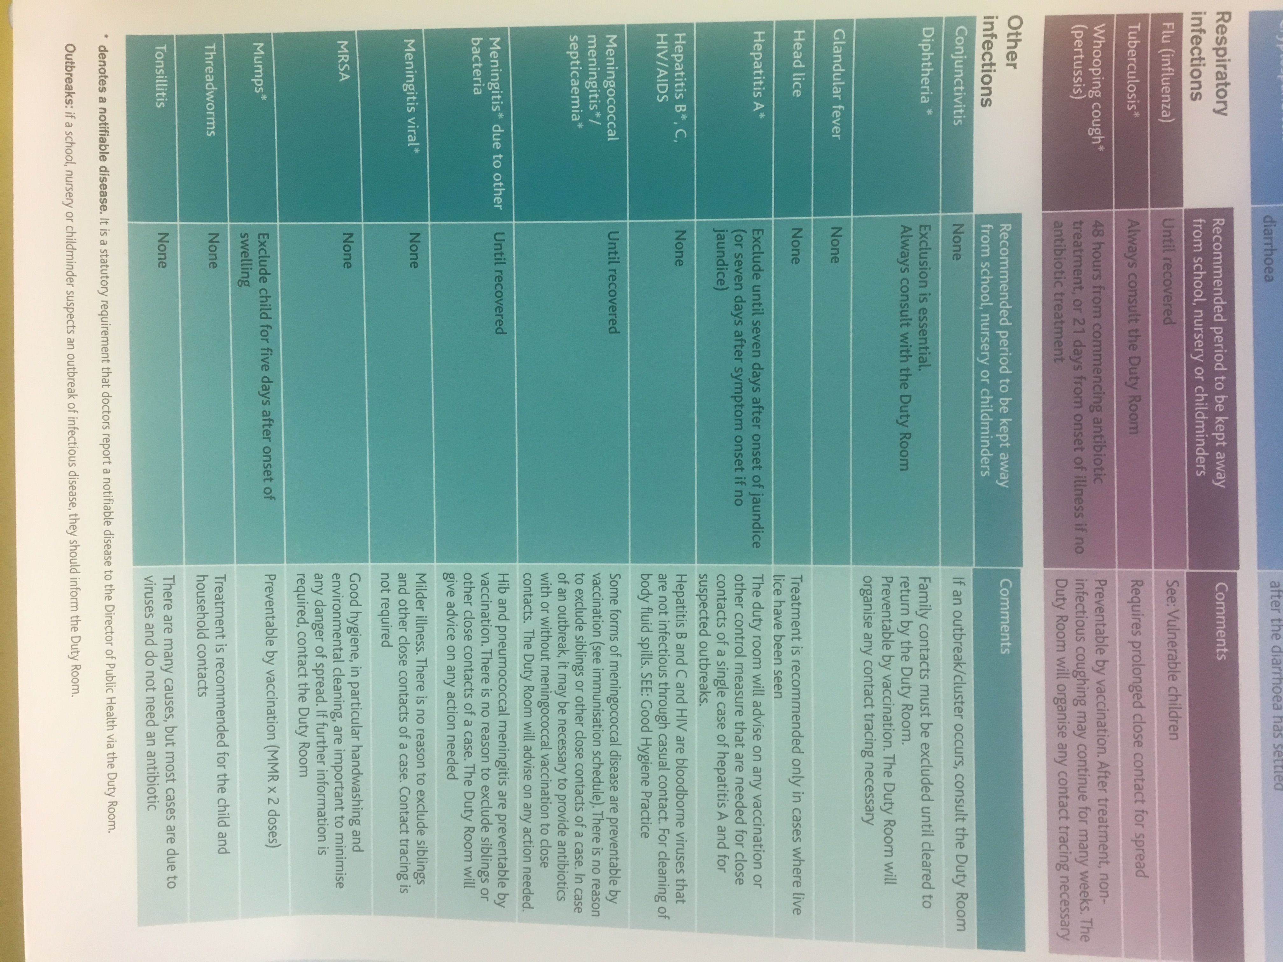

Covid-19 Information

