Anti-Bullying Policy

Agree Date | Review Date | Person Responsible
September 2018 | September 2020 | Mr Smith

Key Language

Target(s) – the child / children who is/are the intentional focus of the child/ children who is/are presenting bullying behaviour.

Introduction

Upper Ballyboley Primary School recognises the negative impact of bullying on a child’s life and the necessity for all members of a school community to act to prevent and act on any such cases should they arise. We, as a school, are committed to safeguarding the wellbeing of all children attending. This policy outlines aims, outcomes, responsibilities and responses, in line with the following legislation and guidance documents:
- Education and Libraries (N.I) Order 2003 – Article 19.
- Addressing Bullying in Schools (Northern Ireland) Act 2016.
- Pastoral Care in Schools: Child Protection (DENI, 1999).
- Pastoral Care in Schools: Promoting Positive Behaviour (DENI, 2001).

Additionally, note has been taken of relevant DENI Circulars for example:
- 2016/20 – Child Protection - Record Keeping in Schools.
- 2015/19 – Notification of Pupil Suspension.
- 2014/14 - Pupil Participation.
- 2013/25 – e Safety Guidance.

Upper Ballyboley Primary School is committed to creating a happy, safe, caring environment where children participate, excel and are proud of their achievements. In order to do this they must be free from the distress caused by the act of bullying.
As part of the Positive Behaviour Policy it was agreed that everyone has a:
- Right to learn & responsibility to behave in a way which enables others to learn
- Right to be safe and the responsibility to behave in ways which keeps everyone else safe both emotionally and physically

We aim to provide a listening, supportive and restorative approach, which enables effective communication between all parties. The aims set out below reflect the overarching aim of this policy: to help children to flourish academically, socially and emotionally in a safe and secure school environment.

Our school’s stated aims are to:  - Create a disciplined yet caring environment where children feel valued and secure. | Outcomes  Children feel valued and secure within a caring and disciplines environment
- Encourage children to realise their own individual potential and develop a sense of self-worth. | Children are confident and achieve
- Identify individual barriers to learning and work collaboratively to reduce them. | Staff and children work together to reduce the barriers which block effective learning

The key principles which underpin our Anti-Bullying Policy are taken from the Governors’ Statement of Written Principles which is found in the school’s Positive Behaviour Policy on page 5:
All members of Upper Ballyboley’s School Community – pupils, parents/ carers, staff (T/NT) & Governors:
- Should show respect and a caring attitude to one another
9 Are entitled at all times to play, work, learn and teach in a safe, secure, happy and caring environment.
- Will work in partnership to identify and meet the needs of those pupils who need additional support to achieve their potential.

Unacceptable Behaviours including Bullying Behaviour

There are many forms of anti-social behaviour which can be grouped under the following categories such as:

- Physical – punch, kick etc.
- Verbal – name calling, threats etc.
- Social Exclusion
- Indirect - Spreading rumours, gossiping, covert etc.
- Cyber – The use of technology to complete verbal and indirect behaviours.

The above types of unacceptable anti-social behaviours do not of themselves constitute bullying behaviour. Following consultation with pupils, parents / guardians, governors and staff, we have agreed that anti-social behaviour becomes bullying behaviour when the following features outlined in our definition below are evidenced:

The School’s Definition
Bullying behaviour:
- Is prolonged, repetitive and persistent.
- Causes a great deal of distress – emotional and physical.
- Is intentional and targeted.
- Usually involves one party / parties having an imbalance of power over another / others.
MOTIVATION:
Various themes or ‘motivations’ often underpin bullying behaviour. This list below indicates possible themes such as:
- Personal appearance
- Racist
- Religious/Sectarian
- Homophobic
- Transphobic
- Disablist/ ‘Ablist’
- Sexist
- Other
The above list is not exhaustive.

Preventative Measures

Prevention of bullying behaviour is a priority for Upper Ballyboley Primary School. Therefore, we actively implement preventative measures, which seek to promote positive behaviour and educate children about the impact of their behaviour towards others.

This includes, but is not limited to:

- Staff delivering the Personal Development and Mutual Understanding curriculum effectively across all Key Stages.
- Educating and empowering pupils to identify and report concerns.
- Delivery and formulation of the school’s Positive Behaviour Policy.
- Ensuring all staff are trained to identify bullying behaviour.
- Effective supervision of children at all times throughout school.
- Promoting positive relationships amongst all staff and pupils.
- Encouraging children to be open and share feelings (for example through impromptu Circle Time to tackle particular issues, use of Worry/Feelings boxes etc.)
- Implementing and monitoring the playground ‘Buddy System’.
- Addressing issues through school assemblies and wall displays.
- School council termly discussion of campaigns / playground and classroom rules.
- Whole school involvement in NIABF’s Anti-bullying week (November).

Consultation and participation arrangements
Parents, Pupils, governors and staff have regular opportunities to:
- Complete baseline audits (October/June).
- Review policy (Bi-Annually)
- Identify key issues arising from feedback received to inform and guide the School Development Planning process (SDP)
- Use emotional mapping to identify and manage school hot spots.

Governors will:
- Monitor and assess policy outcomes (Reoccurring item on the Agenda - Governor minutes for evidence).
- Participate in on-going policy review.

Pupils will:
- Actively participate in School Council Anti-Bullying activities such as designing posters, creating class and school anti-bullying charters, aide -memoirs

Responsibilities

Everyone in the school community has a role in the prevention and handling of bullying incidents. Upper Ballyboley P.S operates on the principle of shared responsibility. The chart on the following page details the main responsibilities of all key stakeholders.

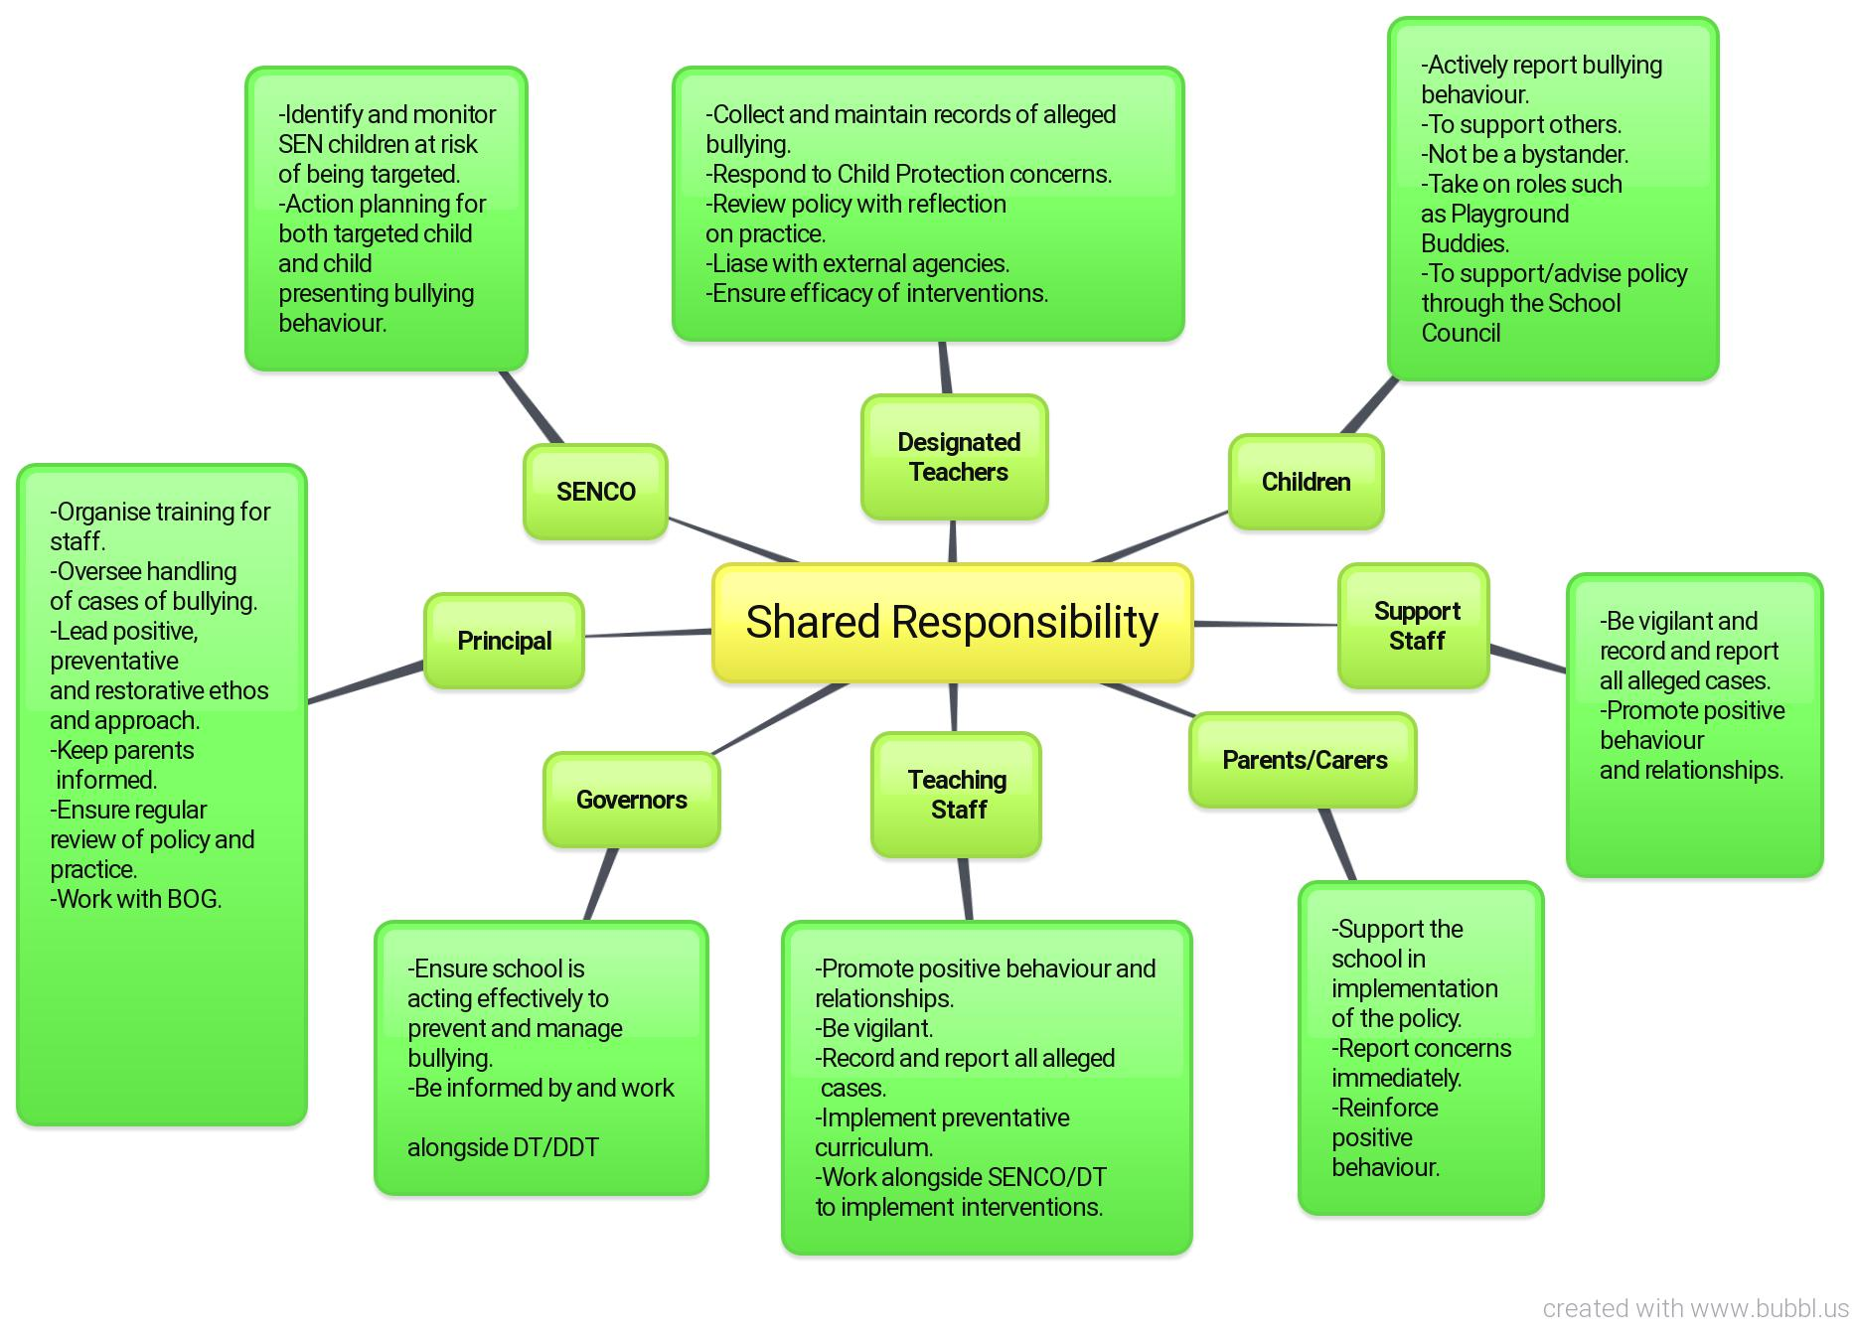

Expression of Concern

THE PROCESS
The diagram below is taken from the “Effective responses to bullying behaviour” (NIABF resource) It illustrates the process to be followed when an incident of alleged bullying is reported to the school.

Procedures

All allegations of bullying must be reported to the Principal/Designated Teacher for Child Protection. The Designated /Deputy Designated teachers will maintain the register of recorded incidents together with details of how the allegation was managed and the outcomes achieved

In the case of alleged bullying, the staff member who responds must first establish the facts of the incident and begin the information gathering process.

This will include:

- Interviewing the alleged target/s and pupil/s displaying bullying behaviour and where possible any adult/s or child witnesses
- Completing a Bullying Concern Assessment Form (see appendix 1)
- Decide on an appropriate intervention using the NIABF resource: Effective Responses to Bullying Behaviour.

The Bullying Concern Assessment form (Appendix 1) will help the staff member to determine on the basis of collated evidence whether the alleged ‘bullying behaviour’ fits the school’s agreed definition of bullying.

If on the basis of the collated evidence the alleged behaviour is shown not to meet the criteria for bullying behaviour (see page 3), then the teacher will refer to the school’s Positive Behaviour Policy.

Recording and Reporting

The flow charts on the following two pages explain the process of a report.

Report made by a pupil

Pupil reports incident to teacher, classroom assistant or playground supervisor

Classroom assistant or supervisor reports to class teacher

Teacher completes report form after investigating the incident and informs principal if further action must be taken

Principal interviews all parties concerned

Bullying Concern Assessment Form completed.
On the basis of the evidence gathered a decision is taken regarding whether the alleged bullying behaviour has or has not met our definition of what constitutes bullying behaviour.
Is
Bullying
Behaviour
Not
Bullying
Behaviour

Parents/carers informed of the decision/outcome by phone call or letter

After investigation, appropriate sanctions will be applied and appropriate support provided

Anti-social behaviour
Positive Behaviour Policy
Bullying behaviour
Anti-Bullying Policy

Report made by a parent/carer

Teacher completes report form after investigating the incident and informs principal on the basis of evidence if further action must be taken

Principal interviews all parties concerned

Bullying Concern Assessment Form completed.
On the basis of the evidence gathered a decision is taken regarding whether the alleged bullying behaviour has or has not met our definition of what constitutes bullying behaviour.

Is
Bullying
Behaviour
Not
Bullying
Behaviour
Parents/carers informed of outcome by phone call or letter

After investigation, appropriate sanctions will be applied and appropriate support provided.

Anti-social behaviour
Positive Behaviour Policy
Bullying behaviour
Anti-Bullying Policy

Interventions: Aims and Support provisions

To provide support for target/ targets. | - To be believed.  - To be supported in overcoming the distress.  - To choose the strategies, which will help them cope with the negative impact of bullying behaviour.  - To strengthen individual resilience. | - Individual Behaviour Plan (IBP – Code of Practice Level 1-5).  - Risk Reduction Plan (Code of Practice Level 1-5).  - The Support Group Method (see Effective Responses to Bullying Behaviour document NIABF, 2011).
To reduce the bullying behaviour of the child / children presenting the behaviour. | - To raise their awareness of the feelings and emotions of others.  - To recognise the impact of their actions on others.  - To develop emotional intelligence and empathy.  - To work actively together with other to reduce their bullying behaviour.  - To acknowledge when they have harmed someone and to know what to do to put it right.
Upper Ballyboley Primary School takes a restorative approach in regards to intervention. Through direct links with the Special Educational Needs Policy support will be provided through implementing one or more of the following interventions:

The key restorative strategies listed below will be used to inform and guide the development of the above interventions.

- Adopting a Solution Focused Approach.
- Enabling pupils to take responsibility for their behaviour – through Worth a Re-think/ Think Discussion Sheet.
- Engaging in dialogue and effective communication.
- Helping pupils to understand the effect of their behaviour on others.
- Undoing harm.

In any support interventions pupils and staff will together evaluate the effectiveness of the strategies and outcomes obtained.

Any bullying intervention should also include some form of sanction in response to unacceptable actions and behaviour in line with school’s Positive Behaviour Policy.

A suspension may be considered once other interventions have failed or required should an exceptional and serious safety situation arise.

Outcomes - Tracking, Monitoring and Assessment of interventions

Staff will work with the target / targets and pupils presenting bullying behaviour to ensure pupil participation and on-going self-assessment of their progress in meeting individual targets (see Special Educational Needs and Disability Act NI 2016 and Quality Indications for The Work of SEN Co-ordinators DENI, 2011).

The Anti-Bullying Register
The Designated Teacher for Child Protection will keep a record of all alleged bullying incidents (using Sims) and track and monitor the outcomes of any planned interventions.
All cases of bullying and subsequent interventions must be monitored and policy reviewed bi-annually.

Policy Review

This policy will be reviewed bi-annually, or following any case of bullying present in the school to ensure that it is meeting the needs of the child and effectively reducing and managing bullying behaviour.
The Designated Teacher for Child Protection will carry out the review, in conjunction with the wider school community.

Professional Development of Staff

The Principal is responsible for the organising of regular and targeted training and Continuing Professional Development related to the preventing and handling of bullying.

The Principal will work in partnership with the Designated Deputy Teacher to plan for the promotion of the school’s anti-bullying message under the remit of Safeguarding and Child Protection.
Appendix 1

Bullying Concern Assessment Form
Part 1- Assessment of Concern Date:
Our Schools Definition of Bullying is:
- Prolonged, repetitive and persistent
- Causes a great deal of distress
- It is intentional
- It usually involves one party having power over another
 | Name (s) | Gender | DOB/Year Group(if Pupil)
Person (s) reporting concern
Name of targeted pupil(s)
Name of pupil(s) involved
Does the behaviour involve:

- Individual to individual
- Group to Individual
- Group to Group
- Individual to Group

Type of incident:

- Physical (includes jostling, physical intimidation, interfering with personal property, punching, kicking, any physical contact)
- Verbal (includes name calling, insults, jokes, threats)
- Indirect (includes isolation, refusal to work with/talk to/play with, gossip)

Is there any apparent theme or motivation? (see Anti-Bullying Policy for potential themes):

Is there persistence/recurrence of this behaviour? Yes/No
Is it targeted behaviour? Yes/No
Is there a power imbalance? Yes/No
Is it intentionally hurtful behaviour? Yes/No
Does this incident meet your school’s agreed definition of bullying? Yes/No
- Check records for previously recorded incidents

Outline of incident(s): Attach all written accounts/drawings of incidents completed by bullied pupil, witnesses (i.e pupils or staff) including dates of events, if known.

PART 2 - Details of interventions to be implemented in response

2.1 PUPIL(s) WHO HAS BEEN BULLIED:
REFER TO LEVEL 1-4 INTERVENTIONS
OUTLINE ACTION/SUPPORT TO BE IMPLEMENTED

____________________________________________________________________________________________________________________________________________________________________________________________________________________________________________________________________________________________________________________________________________________________________________________

Provide outline details of the level and type of intervention with:
peer group _________________________________________________________
whole class_________________________________________________________

On-going support/monitoring to be provided _____________________ (daily, weekly
by________________________________ (named staff) and will be formally reviewed by
_____________________________(date)

Have parent(s) been informed / involved? Yes / No (Give details) ______________________________________________________________________________________________________________________________________

Referral to other agencies- If yes please specify_______________________________
___________________________________________________________________

Any other details (please specify)

2.2 PUPIL(S) WHO HAS BEEN DISPLAYING BULLYING BEHAVIOUR:

REFER TO LEVEL 1-4 INTERVENTIONS
OUTLINE ACTION/SUPPORT TO BE IMPLEMENTED
____________________________________________________________________________________________________________________________________________________________________________________________________________________________________________________________________________________________________________________________________________________________________________________

Provide outline details of the level and type of intervention with:
peer group ____________________________________________________________
whole class____________________________________________________________
___________________________________________________________________

 On-going support/monitoring to be provided _______________________ (Daily, Weekly) by _______________________________ (named staff)

 Have parent(s) been informed / involved? Yes / No (Give details) _________________________________________________________________________________________________________________________________________________________________________________________________________
 Referral to other agencies (please specify) ___________________________________________________________________
 Any other action (please specify) ________________________________________________________________________________________________________________________________________
 Suspension
 Expulsion
 Other (please specify)

____________________________________________________________________

PART 3- ON-GOING RECORD OF SUPPORT AND INTERVENTIONS
REFER TO LEVEL 1-4 INTERVENTIONS

Date | Details of Intervention | Action Required:  Signed:

PART 4 - STATUS OF CONCERN

This concern is now resolved: yes
 Copied to________________________________________
 Filed (Interventions complete, issue resolved, record maintained)

When concern is not resolved:
Further intervention/ Required
 Review information and action to date
 Refer to Principal/Designated Teacher
 Re-assess Level of Interventions; Implement other strategies from appropriate level
 Assign tasks, record and monitor as in Part 2 & 3

Name and designation of the teacher completing this form:

________________________________________________________________________
Signed:
Date

