

**The Price of Coke**

$\frac{1}{3}$**litre**

**1 litre**

**250 ml**

**500 ml**

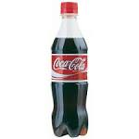



**89p**

**47p**

**42p**

**66p**

The capacity of each container of coke is shown above. The cost of each full container of coke is also shown.

Work out how many different prices you could pay for   
**2 litres** of coke by using combinations of different sizes.

**For example:**

1 litre + 500ml + 500ml = 89p + 66p + 66p = £2.21

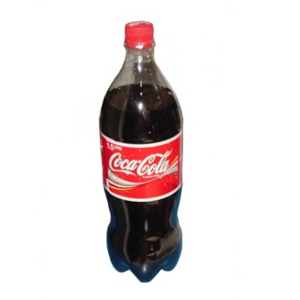

Now try to find all the other possible costs.

**£1.17**

**Going Further**

If there is also a 1½ litre bottle of coke available for £1.17 how many different prices could you pay for **3** litres of coke.