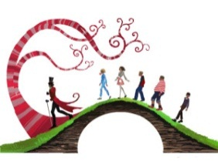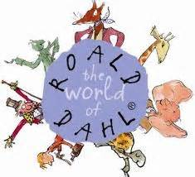

**Dahl Delights**

In Farben Primary School there are four Primary 5 classes. A survey was carried out to find out about the favourite books of Roald Dahl. Use the set of clue cards to complete the table below.

|  |  |  |  |  |  |
| --- | --- | --- | --- | --- | --- |
| **Class Teacher**  **Book Title** |  |  | **Mr Plum** |  | **TOTAL** |
| **Matilda** |  | **6** | **7** |  | **20** |
| **Charlie and the Chocolate Factory** | **2** |  |  | **6** |  |
| **The Witches** |  | **1** |  | **3** | **16** |
| **Danny the Champion of the World** |  |  | **4** |  | **8** |
| **James and the Giant Peach** | **4** |  | **2** |  |  |
| **The BFG** |  | **6** |  | **7** |  |
| **The Twits** | **0** |  | **1** |  | **9** |
| **George’s Marvellous Medicine** | **4** | **4** |  | **3** | **13** |
| **TOTAL IN CLASS** | **25** | **28** |  | **29** |  |

When you have completed the table don’t forget to draw a graph of your results

**Carry out a survey in your class to find out about favourite Roald Dahl books or about books by a different well-known author. Use the computer to present your results.**



**EXTRA**

**Dahl Delights Clue Cards**

|  |  |  |
| --- | --- | --- |
| MCj04326450000[1]How many pupils took part in the survey altogether? | MCj04326450000[1] Overall, *Charlie and the Chocolate Factory* was twice as popular as *James and the Giant Peach.* | MCj04326450000[1] Produce a graph showing the results of the survey. |
| MCj04326450000[1]*The Witches* was equally popular in Mr Plum’s class as in Mrs Grey’s class. | MCj04326450000[1] An **even** number of pupils in Mr Plum’s class liked *The Witches.* | MCj04326450000[1] There are two fewer pupils in Mr Plum’s class than in Mrs Lemon’s class. |
| MCj04326450000[1]Miss Gold is the teacher of the only class in which an **odd** number of pupils liked *George’s Marvellous Medicine.* | MCj04326450000[1] In Mrs Grey’s class *Danny the Champion of the World* was only half as popular as *Charlie and the Chocolate Factory.* | MCj04326450000[1] In Miss Gold’s class *James and the Giant Peach* was only half as popular as it was in Mr Plum’s class. |
| MCj04326450000[1]In Miss Gold’s class, *Matilda* was twice as popular as *James and the Giant Peach* in Mr Plum’s class. | MCj04326450000[1] In Mrs Lemon’s class *The Twits* was only half as popular as *Matilda.* | MCj04326450000[1] In Mrs Lemon’s class one person fewer liked *George’s Marvellous Medicine* than *Charlie and the Chocolate Factory.* |